BetterDay

Use Case Diagrams

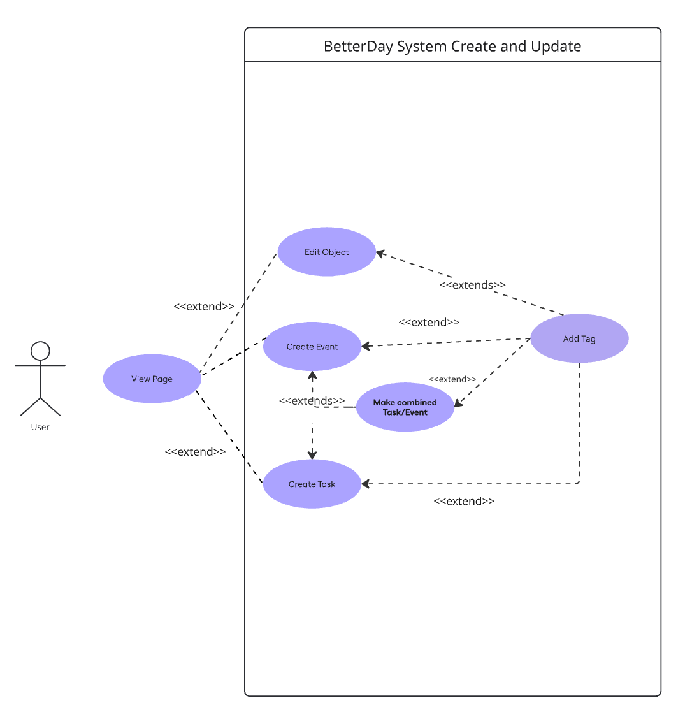

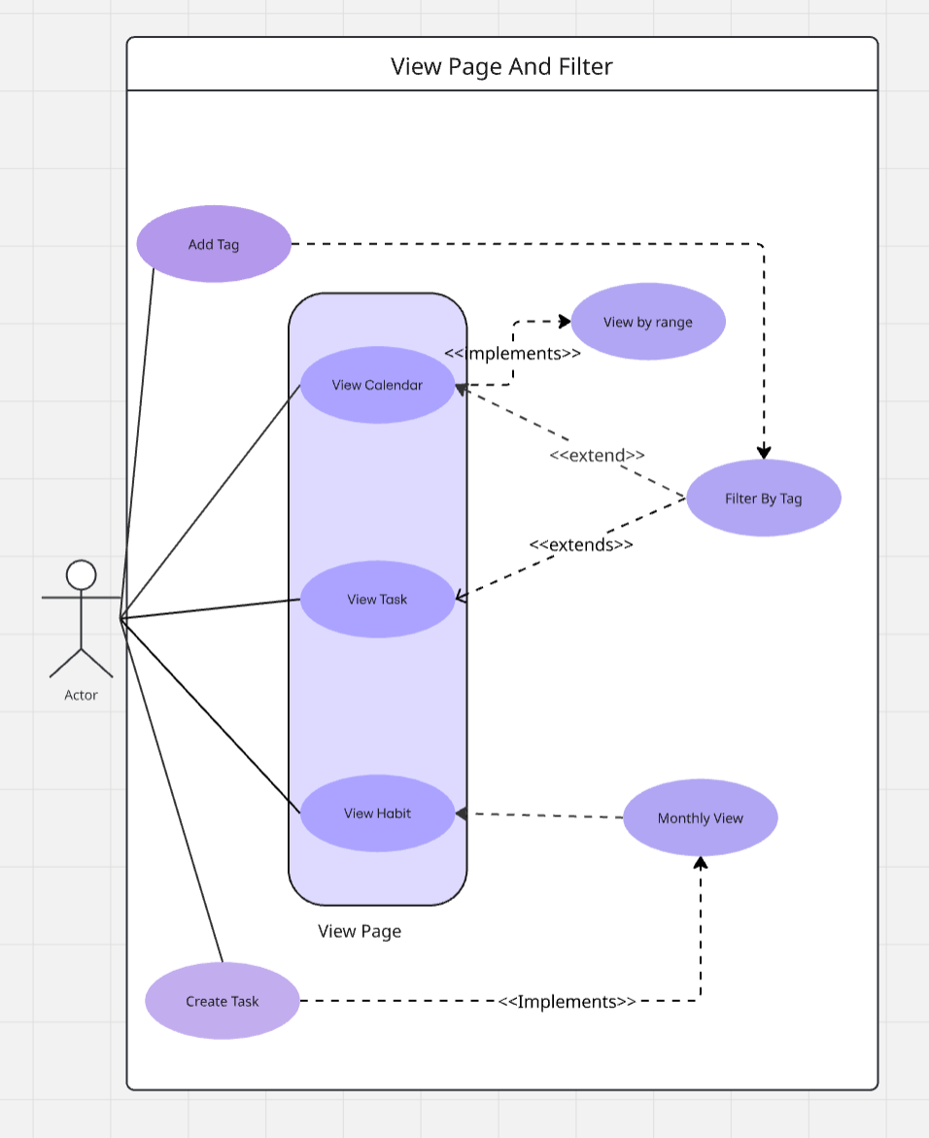

Use Cases
Name/Title: | (1) View [Page] (e.g. View Calendar, View Tasks, View Habit)
ID: | 1
Description: | Switches between the calendar, task, and habit pages
Related Use Cases: | Inclusions:<10 View By Range>  Extensions: <2 Create Event>, <3 Create Task>, <7 Edit Object>, <9 View By Range>, <10 Filter By Tag>,
Precondition: | App is open
Success Postcondition: | View swaps to another screen view

USER STEPS:  1. User has app open  2. User presses button on menu bar  2.a User presses Calendar button (3.a.)  2.b. User presses Task button (3.b.)  2.c. User presses Habit button (3.c) | SYSTEM RESPONSE:  3. Page changes to the case of the selected icon  3a.display changes to calendar page  3b. Display changes to task page  3.c. Display changes to habit page

Name/Title: | (2) Create Event
ID: | 2
Description: | Creates a new event
Related Use Cases: | Extension: <1 View [Page] - Calendar>,  Extends: <4 Make Combined Task/Event>, <5 Make Recurring>, <6 Add Tag>, <7 Edit Object>
Precondition: | User must be on the Calendar page
Success Postcondition: | Event will appear on Calendar

USER STEPS:  1. User presses the + icon on the eventscreen  3. User taps area for event name  5. User types in name of task  6. User confirms entry  8. User opens start time field  10. User selects start date  12. User selects end time field  14. Optional: User fills in other fields  a. Optional: use case 3 add tag  3.b Optional: use case 4 make recurring  3.c. Optional Use case 5 make event  15. User taps the checkmark to confirm | SYSTEM RESPONSE:  2. System brings up modal for new task  4 Keyboard appears  7. Task name is updated on screen  9. Rolodex style date and time selector appears  11. System updates start date field  13. System selects rolodex  - Colors updated  16. Task is created, updates task list

Name/Title: | (3) Create Task
ID: | 3
Description: | User Creates a new Task Object
Related Use Cases: | Extends: <1 View [Page] - Tasks>  Extensions: <4 Make Combined Task/Event>, <5 Make Recurring>, <6 Add Tag>, <7 Edit [Object]>  Included By: <8 Monthly View>
Precondition: | Must be on the View Task screen
Success Postcondition: | Task and its associated data is saved and can be viewed on task screen

USER STEPS:  1. User presses the + icon on the task screen  3. User taps area for task name  5. User types in name of task  6. User confirms entry  8. Optional: User fills in other fields  a. Optional: use case 6 add tag  3.b Optional: use case 5 make recurring  3.c. Optional Use case 4 make combined [object]  9. User taps the checkmark to confirm | SYSTEM RESPONSE:  2. System brings up modal for new task  4 Keyboard appears  7. Task name is updated on screen  8. Display shows added features  10. Task is created, updates task list

Name/Title: | (4) Make Combined Task/Event
ID: | 4
Description: | This option will appear in both the task and event creator to make it have the properties of both an event and a task and appear on both displays.
Related Use Cases: | Extends: <1 View [Page] –Calendar or Tasks>, <2 Create Event>, <3 Create Task>,  Extensions: <7 Edit Object>, <6 Add Tag>, <5 Make Recurring>
Precondition: | User is in the modal for a task or event  a) in modal through Create Task or Create Event  b) in modal through Edit Task or Edit Event
Success Postcondition: | The new information will save the combined data item to both tasks and events and the object can be viewed in either display.

USER STEPS:  1. User has modal up for object creation  1a. User is creating a new task/event  1b. User is editing an existing task/event  2. User taps icon to make combined task/event  5 Continue  5a User continues Create Event/Task  5b User continues Edit Event/Task | SYSTEM RESPONSE:  3. System changes object type to be both task and event  4. System updates  4a. Task is updated to Calendar  4b. Event is updated to Tasks

Name: | (5) Make Recurring
ID: | 5
Description: | As a user, I want to be able to have an object become recurring
Related Use Cases | Extends: <2 Create Event>, <3 Create Task>, <4 Make Combined Task/Event>, <7 Edit Object>  Extensions: <6 Add Tag>
Precondition | Modal is up:  - User either is creating a new object  - User is editing an existing object
Success Postcondition: | Task will repeat at the specified interval

USER STEPS:  1. User creates a new task  3. User selects box for recurring event  5. User inputs frequency  5.a User optionally inputs start date  5.b User optionally inputs end date  6. User confirms event creation | SYSTEM RESPONSE:  2. Modal for task tags and options appears  4. System displays days and date range for recurring event  7. Task is created and duplicated for each occurrence.

Name/Title: | (6) Add Tag
ID: | 6
Description: | Applies tags to events and tasks for future filtering
Related Use Cases: | Extension: <2 Create Event>, < 3 Create Task>, <7 Edit Object>  Include: <10 Filter by Tag>
Precondition: | User has modal up  a)Creating new Task/Event  b)Editing Existing Task/Event
Success Postcondition: | Tag has been added to object event and/or task. Will be able to filter by tags on View [Page]

USER STEPS:  1. User Entered Modal Screen  1a. User created new object  1b User is editing existing object  2. User selects existing tag (go to 6)  2a. User selects new tag (go to 4)  5. User types in name of new tag  6. User confirms tag  9. Continue object create/edit | SYSTEM RESPONSE:  4. Keyboard appears  7. System applies tag to event/task  8. List of tags updated to filter

Name: | (7) Edit Object (e.g. Task, Event, Combined)
ID: | 7
Description: | User selects an existing object: task, event, or combined and changes existing fields associated with it
Related Use Cases: | Extends: <2 Create Event>, <Create Task>, <4 Make Combined Task/Event>  Extension: <5 Make Recurring>, <6 Add Tag>
Precondition | There is an existing created object and the user taps on the object
Success Postcondition: | Properties of the object are changed

USER STEPS:  1. User selects an object  1a. User selects an Event  1b. User selects a Task  3. User makes changes  3a. User adds tag (Use Case 6)  3b. User Makes recurring (Use Case 5)  3c. User makes Combined Task/Event (Use Case 4)  5. User confirms changes | SYSTEM RESPONSE:  2. Editing Modal appears  4. System shows new changes on display  6. System saves fields of the object.  7 System refreshes for View [Page]

Name/Title: | (8) Monthly View (Habit)
ID: | 8
Description: | This displays colored icons over a calendar view to show how well the user has been completing tasks
Related Use Cases: | Extends: <1 View [Page] Habit>  Include: <3 Create Task>
Precondition: | On View [Page] Habit
Success Postcondition: | Changes made to the event will be updated and saved

USER STEPS:  1. User is on the View [Page] Habit  2 User presses Monthly View  4. User can select previous day to view Habit for that day | SYSTEM RESPONSE:  3. System updates monthly view with created tasks

Name/Title: | (9) View By [Range]
ID: | 9
Description: | Switches Calendar View between Daily, Weekly and Monthly
Related Use Cases: | Included by: <1 View [Page]-Calendar>
Precondition: | User is on App
Success Postcondition: | User Changes Calendar view

USER STEPS:  1. User selects Calendar  3. User Selects an alternate range | SYSTEM RESPONSE:  2. System implements Shows last calendar view  2a finish  4. System Displays alternate range

Name/Title: | (10) Filter By Tag
ID: | 10
Description: | Task or Calendar View is filtered by Existing Tags
Related Use Cases: | Extensions: <1 View Page>  Incude: <6 Add Tag>
Precondition: | A filter exists and user is on View [Page] Task or Calendar
Success Postcondition: | View is filtered to only show where match is true

USER STEPS:  1. User Presses Menu Button  3. User Presses Filter Button  5. User presses text to represent existing tags  5a User presses text again to remove tag from view | SYSTEM RESPONSE:  2. Menu sidebar Appears  4. Filter Modal Appears  6. System checks objects displayed in Page [View] against tags  7. System shows only objects that match existing tags

